MANCHESTER,UK-After travelling through Japan and making extensive field recordings of places and events in Tokyo, Osaka and Kyoto, ConfettiTsunami returned back to Manchester with an idea to turn these into a travelogue.
“Made in Japan” evolved organically from this original idea. Interweaving the field recordings with compositions written whilst in Japan, and developing them back home in Manchester, ConfettiTsunami creates music that drifts between experimental electronica and dance music.
Crafted out of passion and a yearning to relive the familiar, and inspired by electronic luminaries such as Boards Of Canada, Aphex Twin and Oneohtrix Point never, 'Made In Japan ' is a nostalgic trip of a real life experience that is both reflective and sincere; an album that any fans of electronic music won’t want to miss.

Album available from; https://confettitsunami.bandcamp.com/album/made-in-japan For more Information, promotional requests or to arrange an interview contact Directly via Artist@confettitsunami.co.uk or visit www.confettitsunami.com.

Track Listing:

1. MADE IN JAPAN
2. TOKUDAWARA
3. LOCKS
4. SHRINE
5. AIRPORT PIANOS
6. SUBWAY UNDERPASS
7. YAMANOTE LINE [25/26-00H76M03S]
8. OSAKA NIGHTS
9. COLLAPSE
10. NOSTALGIA
11. PAST & YOYOGI PARK
12. KULTARA
13. TSUKIJI
14. LEAVING

ALBUM ARTWORK:
Front
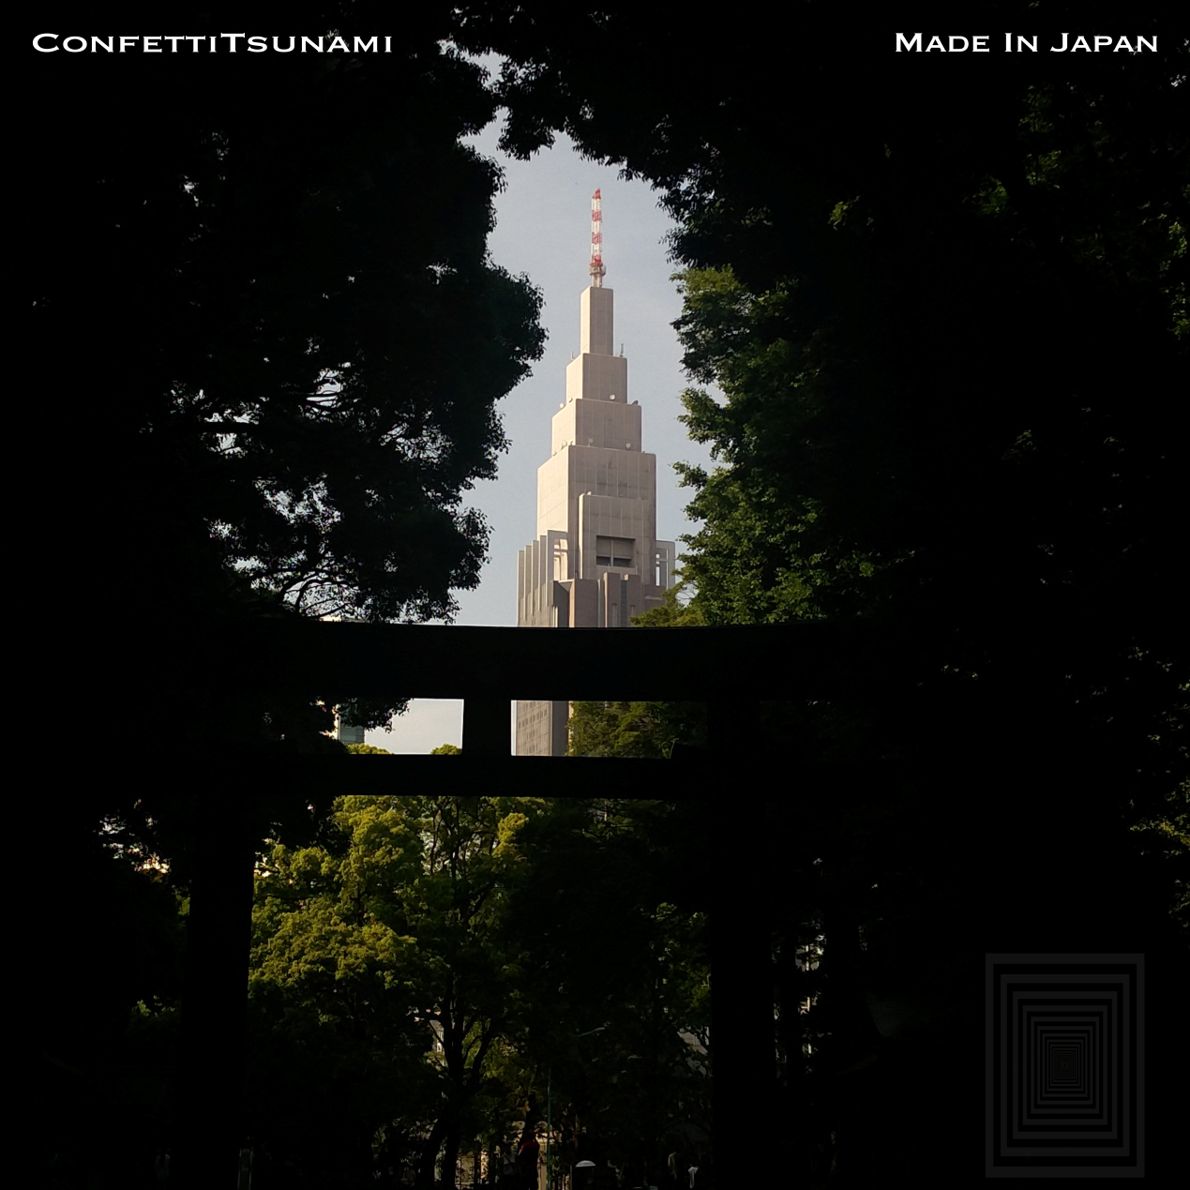

BACK
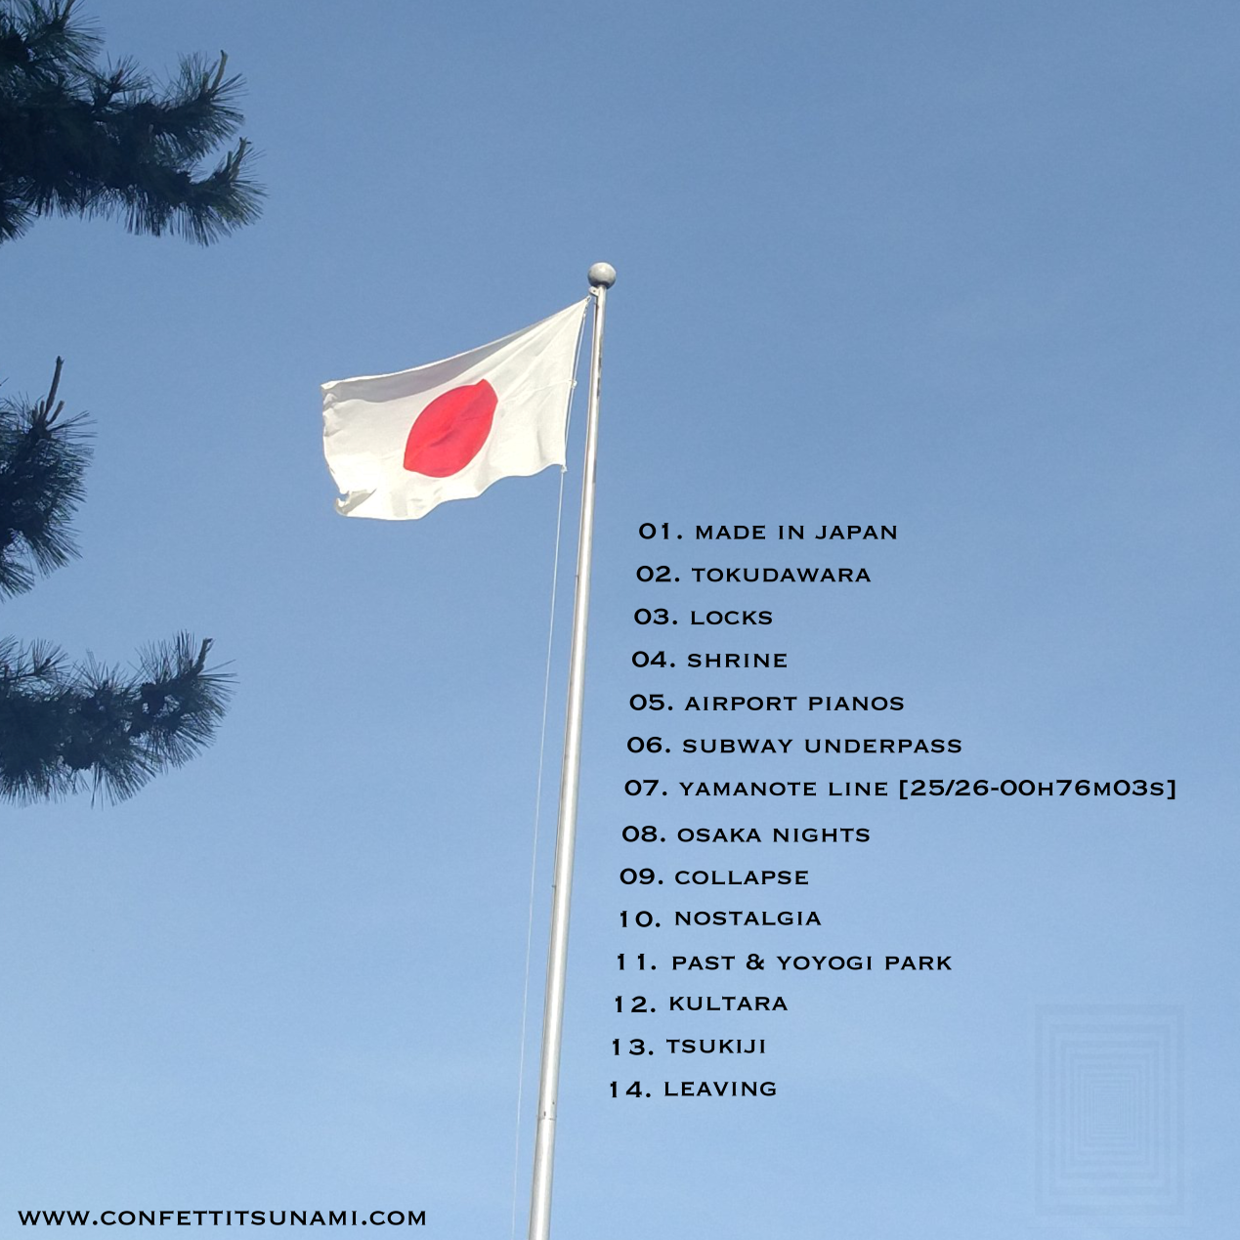

Artist Pictures

